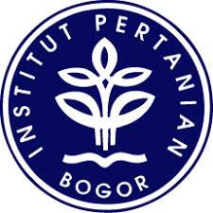

**SEMINAR**

**SEKOLAH PASCASARJANA**

**INSTITUT PERTANIAN BOGOR**

**2019**

|  |  |  |
| --- | --- | --- |
| NAMA | : | RICARDUS KEIYA |
| NRP | : | I353160101 |
| PROGRAM STUDI | : | SOSIOLOGI PEDESAAN (SPD) |
| JUDUL PENELITI | : | M MERAUKE INTEGRATED FOOD AND ENERGY ESTATE : STUDI KASUS *LAND GRABBING* DI MERAUKE PAPUA |
| KOMISI PEMBIMBING | : | 1. DR. IR. SOERYO ADIWIBOWO, MS. 2. DR. IR. TITIK SUMARTI MC, MS. |
| HARI/TANGGAL | : | SENIN/08 JULI 2019 |
| WAKTU | : | 13.00 WIB-14.00 WIB |
| TEMPAT | : | RUANG 305 SPs Lt. 3, GEDUNG PASCASARJANA  IPB DRAMAGA |